AWS SQS
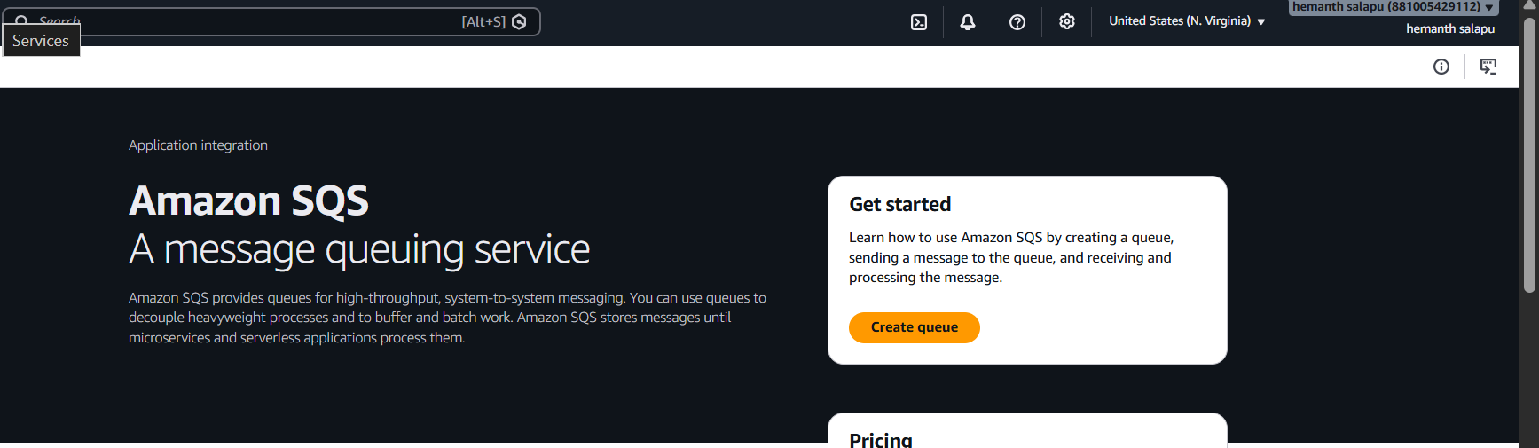
Create a new queue
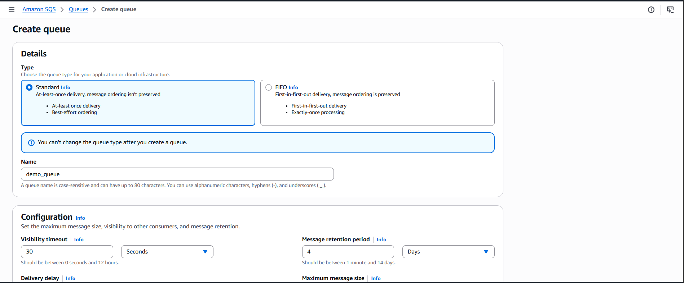
Created a new SQS in AWs
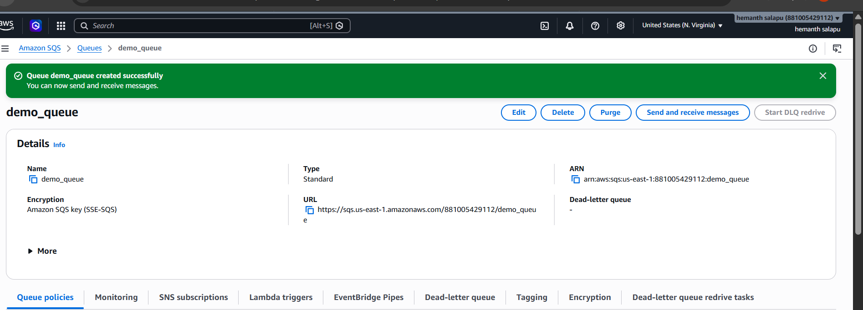
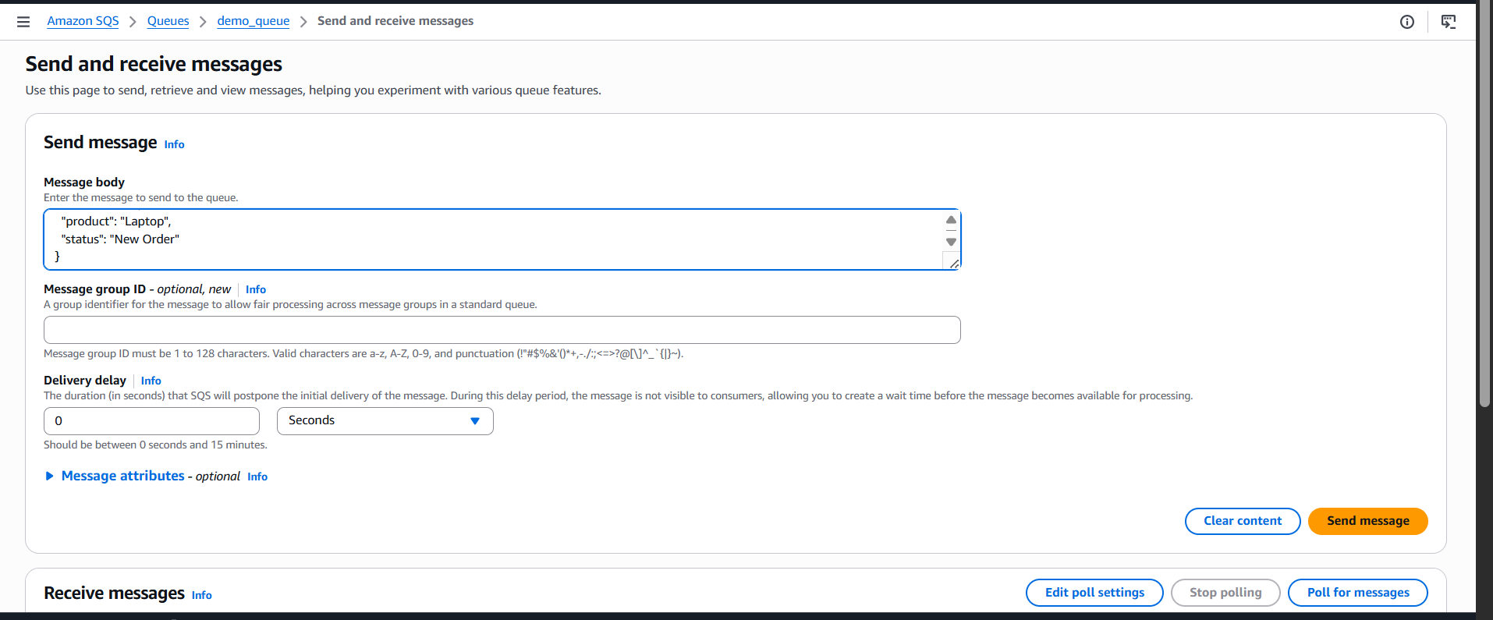
Then click on send and receive messages and then click on send message and
type the required message
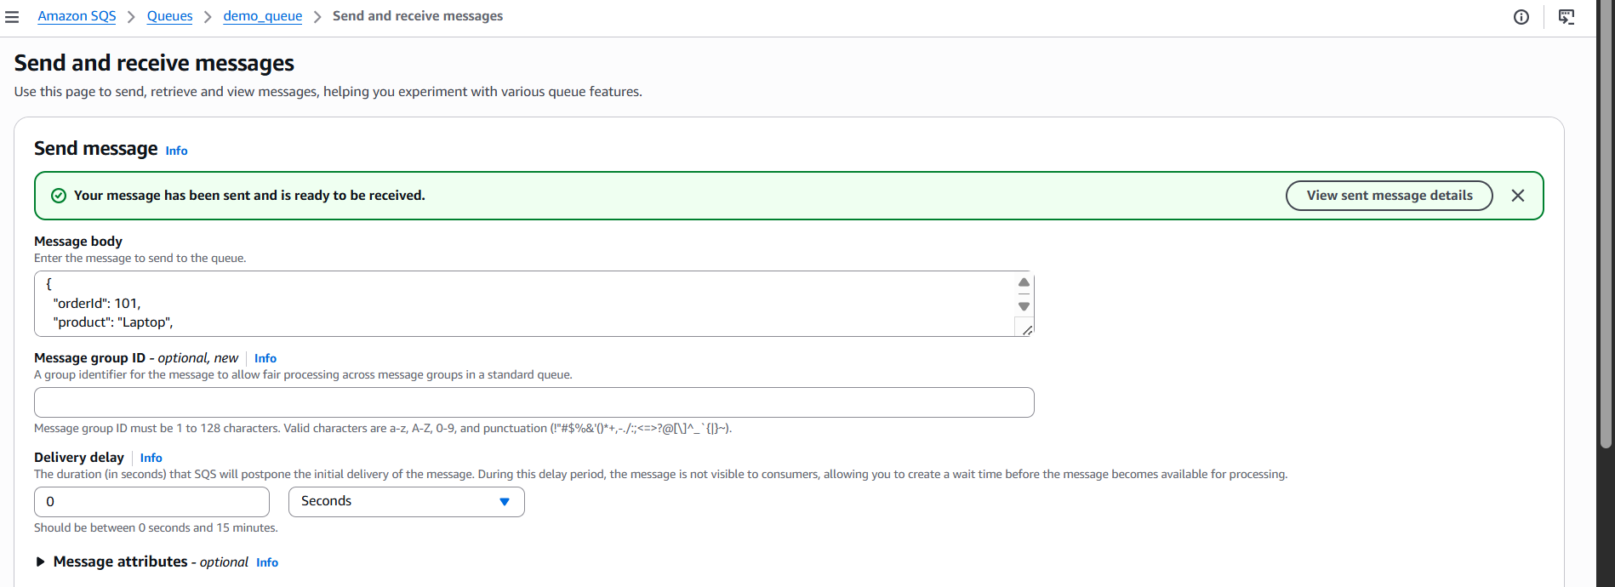

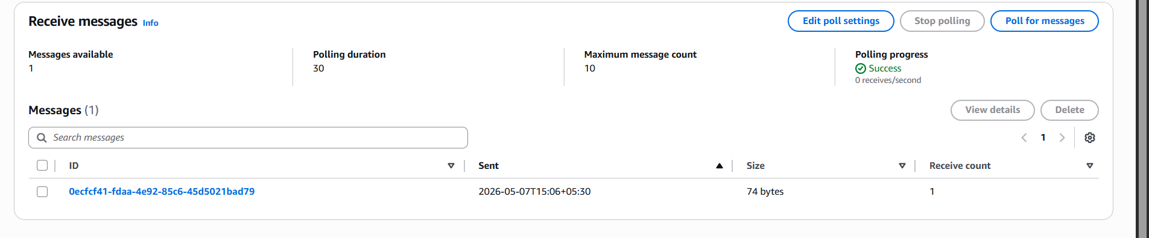
Then scroll down and click on receive message option and then poll message
and then click on the message you see on the screen and then you will be able
to see the message
